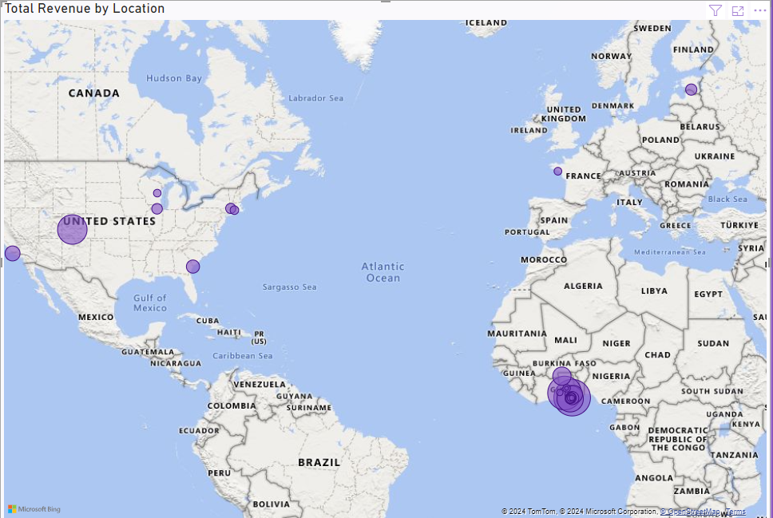

**Power BI Project:**

**Amazon E-Commerce**

Name: Ashwin Dubey

Project Name : Amazon E Commerce

Date: 14/03/2024

**Objective Questions:**

1. What is the total number of attributes in the customer table?

Ans: **In customer table initially had three attributes: Customer ID, Customer Age, Customer Gender**

1. How will you get the “Customer’s” ages in the “Order” tables according to customer IDs?

Ans: **To calculate the customer's age in the Orders table, apply the following DAX formula in Power BI:**

**DAX Formula: Customer Age = LOOKUPVALUE(Customers[Age], Customers[CustomerID], Orders[Customer ID])**

**This formula will match the Customer ID in the Orders table with the Customer ID in the Customers table and return the corresponding Age from the Customers table.**

1. In analyzing the dataset with Power BI, ensure data cleaning to address inconsistencies and missing values before further analysis.

Ans:

* + **Column Header Formatting:**

**Space given in the column header name of ‘Order Date’ .**

* **Null values in ‘Reason’ Column of Orders Table**

**Replaced null values of ‘Reason’ column of Orders Table with ‘Successfully Delivered’**

Before replacing null values:

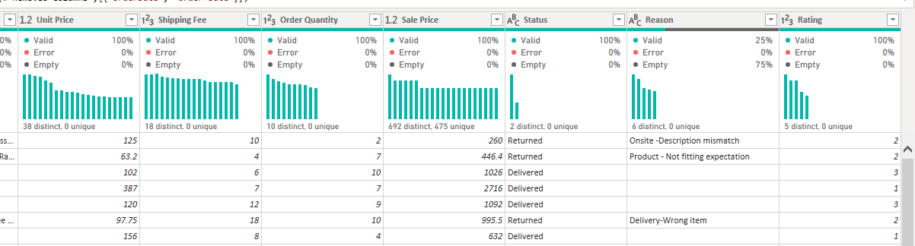

After replacing null values:

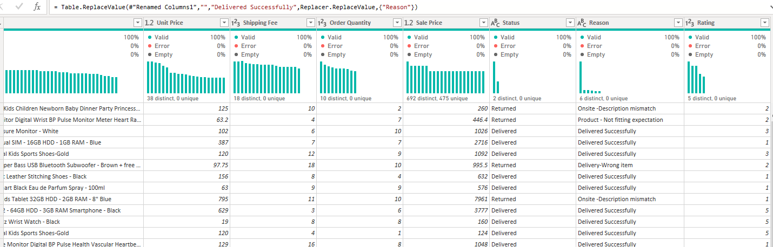

* + **Null Columns in Orders Table:**
    - **After getting data in Power Query Editor “5” Null Columns seen in Orders Table.**
    - **Deleted Null Columns.**

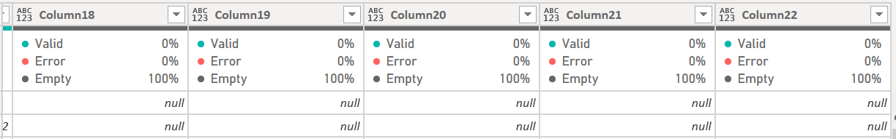

* + **Blanks in Product Category Column:**
    - **One blank found in Product Category Column.**
    - **To fill this null value it is matched with Subcategory and null of ‘Product Category’ is replaced by ‘Health and Beauty’.**

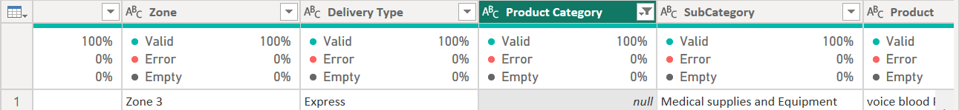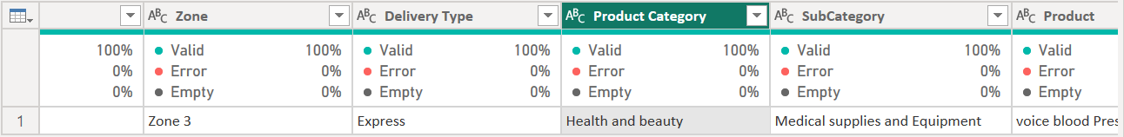

* + **Blanks in Order Quantity and Unit Price Column:**
    - **In order to maintain purity of data, blanks replaced with “0” because if we insert average Order Quantity and Average Unit Price of then it will hampers Sale Price.**

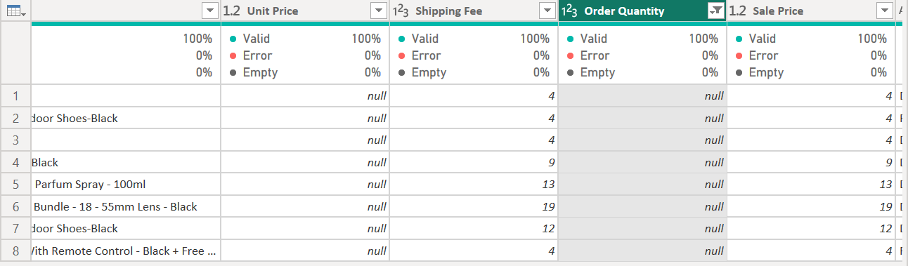

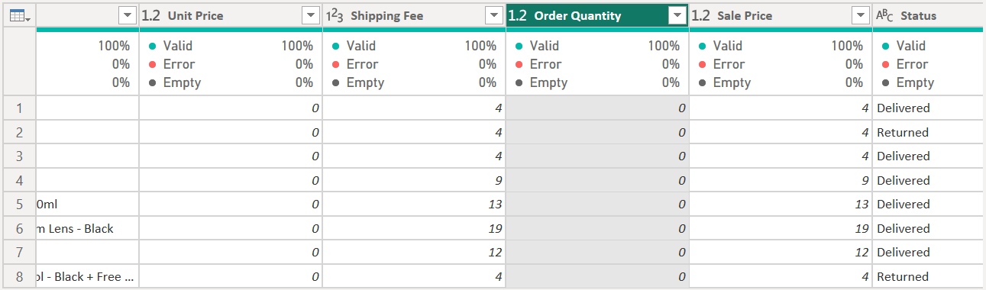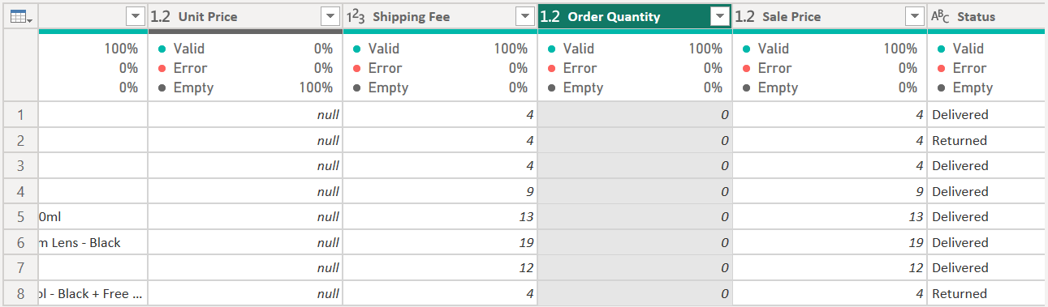

**For Customers Table,**

* + **Blank in Customer Gender Column:**
    - **One blank found in Customer Gender Column.**
    - 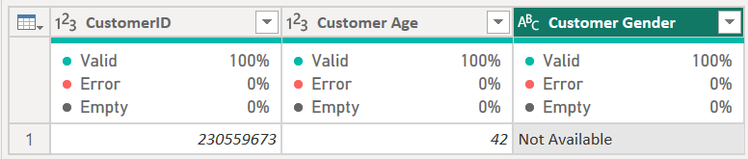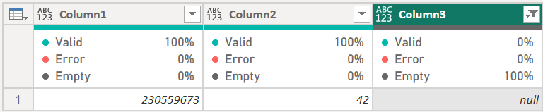**In order to handle blank replaced Not Available.**
  + **Customer Gender:**
    - **“M” replaced with “Male”.**
    - 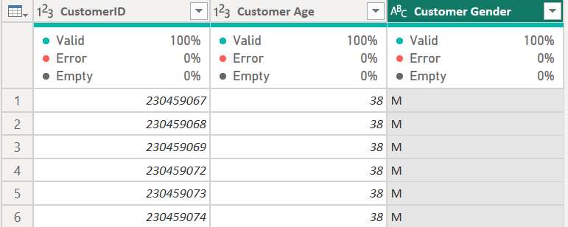**“F” replaced with “Female”.**

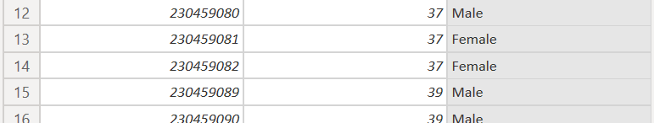

* + **Added new column “Age Group”:**
    - **In order to get Customer Age created “Age Group” by using “Conditional Column”.**

1. How can we calculate the total revenue generated by all the sales?

Ans: **- To compute the total revenue from all sales in Power BI, you can use the following DAX measures:**

* **Total Revenue:**
* **Measure: Total Revenue = SUMX(Orders, Orders[Revenue Delivered] + Orders[Revenue Returned])**
* **This measure calculates the total revenue by adding the ‘Revenue Delivered’ and ‘Revenue Returned’ summing the results.**
* **Net Revenue (after accounting for returns):**
* **Gross Revenue: The initial calculation of revenue from all sales.**
* **Measure: Revenue Gross = SUM(Orders[Sale Price])**
* **Returned Revenue: The revenue from sales that were later returned.**
* **Measure: Revenue Returned = SUMX(FILTER(Orders, Orders[Status] = "Returned"), Orders[Sale Price])**
* **Delivered Revenue: The revenue from the dale that were delivered**
* **Measure: Revenue Delivered = SUMX(FILTER(Orders, Orders[Status] = " Delivered "),**
* **Net Revenue: The final measure that provides the net total revenue.**
* **Measure: Revenue Net = [Revenue Gross] - [Revenue Returned]**

**When added to a Power BI report, the ‘Revenue Net’ measure determines the net total revenue by subtracting the ‘Returned Revenue’ from the ‘Gross Revenue’. This approach allows you to analyse sales performance while considering returns.**

1. What is the total number of unique customers who made purchases each year? Is there any increase in the number over the years?

Ans: **- The total number of unique customers who made purchases each year is “113k”**

**In order to get the total number of unique customers who made purchases each year need to use Measure**

**Measure: Unique Customers Per Year = CALCULATE(DISTINCTCOUNT(Orders[Customer ID]), ALLEXCEPT(Orders, Orders[Year]))**

**“Remarkable Growth: Unique Customer Purchases Surge in 2020”**

**Upon analysing the data with the measure 'Unique Customers Per Year', we observe a substantial increase in the number of unique customers making purchases annually. The most pronounced growth occurred from 2019 to 2020, where the figure soared to roughly 25.2k unique customers, a significant rise from the steady count of about 17.5k in preceding years.**

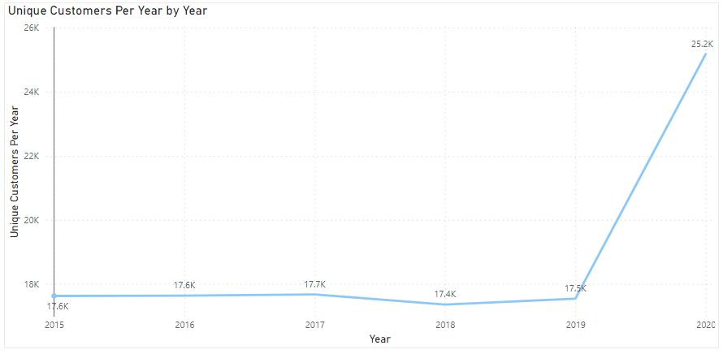

1. How can we determine the total number of unique products available in the company?

Ans: **To identify the total number of unique products the company offers, apply this DAX formula in Power BI:**

**Total Unique Products = DISTINCTCOUNT(Products[Product ID])**

**This counts each unique ‘Product ID’ in the ‘Products’ table, yielding the total unique product count.**

1. What is the average number of days it takes for products to be delivered, get the metric for only the delivered orders.

Ans: **Streamlined Deliveries: Power BI Reports Average Time of 9.41 Days for Order Fulfilment  
  
To calculate the average number of days required for product delivery, specifically for orders that have been confirmed as delivered, the following DAX formula is used in Power BI:**

**Measure: Average Delivery Time = AVERAGEX(FILTER(Orders, Orders[Status] = "Delivered"), DATEDIFF(Orders[Order Date], Orders[Delivery Date], DAY))**

**This measure filters the 'Orders' table to include only those with a status of "Delivered". It then calculates the difference in days between the 'Order Date' and 'Delivery Date' for each delivered order using the `DATEDIFF` function. Finally, it averages these differences across all delivered orders with the `AVERAGEX` function. The measure is named 'Average Delivery Time' and when added to a Power BI report, it provides the mean delivery duration, which is “9.41 days” in this case.**

1. Which products, categories, and subcategories are the most popular?

Ans: **The analysis of sales data reveals the most popular products, categories, and subcategories based on updated order quantity:**

* **Most Popular Products:**
* **Avon Soft Musk Eau de Toilette Spray – 50ml: 14,444 in order quantity sold total.**
* **Most Popular Categories:**
* **Health and Beauty: Approximately 1,98,550 in order quantity sold total.**
* **Most Popular Subcategories:**
* **Vitamins & Dietary Supplements: Close to 70,553 in order quantity sold total.**

**This data indicates customer preferences and highlights the sales performance across different segments of the company’s product offerings**

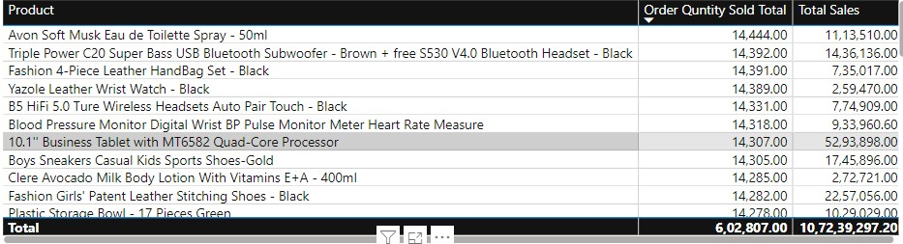

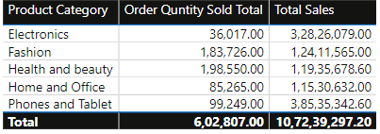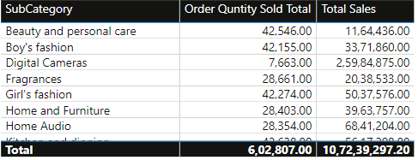

1. Which products have seen an increase or decrease in sales over the year?

**Ans**: **Analysis of Product Sales Trends Over the Year**

**To assess which products have experienced changes in sales over the year, we followed these steps:**

* **Create a Line Chart:**
* **We set up a line chart in Power BI.**
* **The chart uses the following axes:**
* **X-Axis: Year**
* **Y-Axis: Total Revenue**
* **Each product is represented by a separate line.**
* **Observations and Conclusions:**
* **After analyzing the line chart, we draw the following conclusions:**
* **Sales trends vary significantly across different products.**
* **Some products exhibit consistent growth year-on-year.**
* **Others experience seasonal fluctuations or occasional spikes.**
* 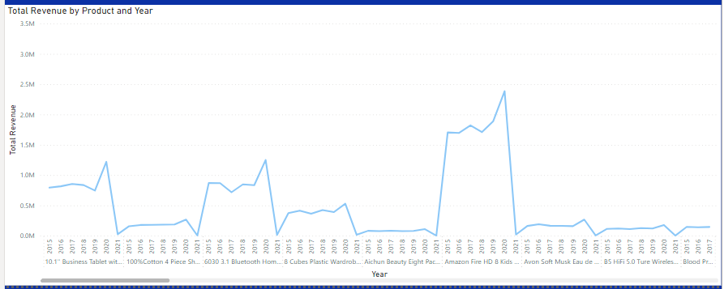**It’s essential to delve deeper into the data to understand the underlying factors driving these trends.**

1. While modelling the data relationships, what will be the type of relationship between the customer ID of Orders and customer tables?

**Ans**: **While Data Relationship Modelling in Power BI**

* **Relationship Type: One-to-Many**
* **Customers Table**

**The Customers table contains a list of customers. Each row represents a single customer and includes their contact details and other relevant information. The Customer ID serves as the primary key in this table.**

* **Orders Table**

**The Orders table represents orders placed by customers. Each row corresponds to an order. The Customer ID field in the Orders table links back to the corresponding customer record in the Customers table. This establishes a one-to-many relationship between orders and customers.**

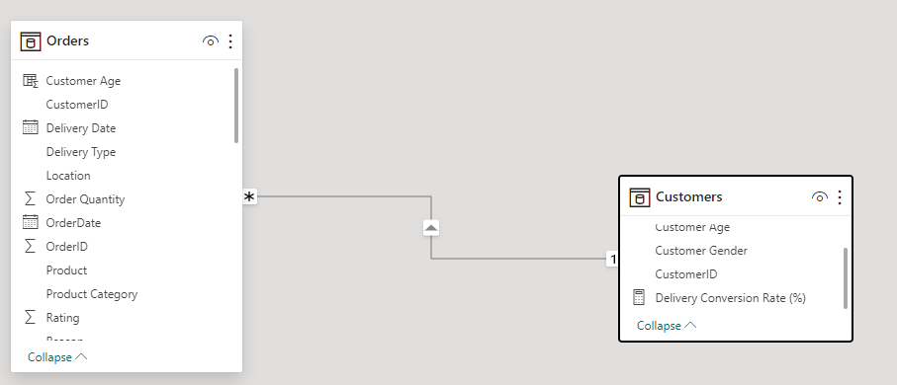

1. How have you handled the null values in the data?

**Ans**: **- During data cleaning in Power BI, I addressed null values using the following steps:**

* **Null Columns in Orders Table:**
* A screenshot of a computer

  Description automatically generated**Identified and deleted the “5” null columns in the Orders Table.**
* **Reason Column:**
* 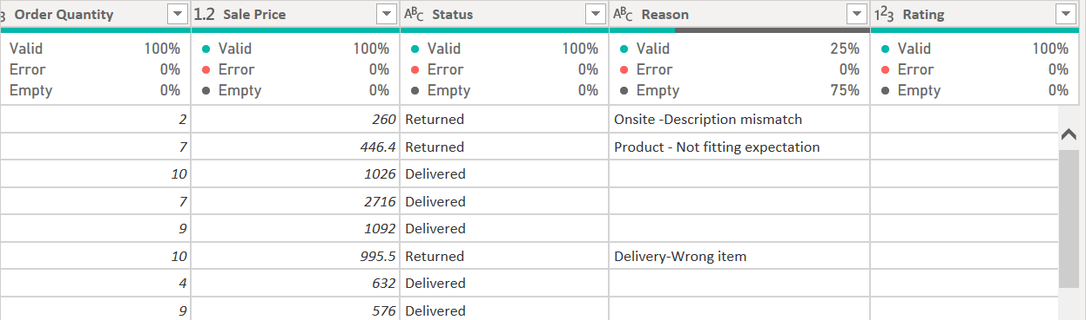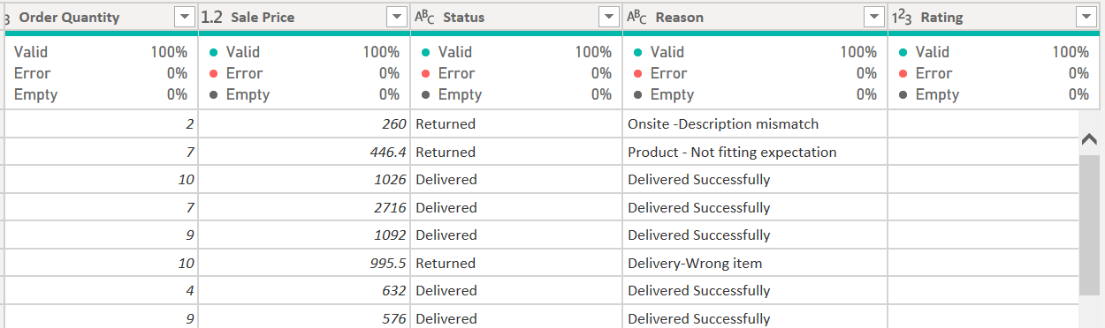**Replaced blanks with “Delivered Successfully.”**
* **Product Category Column:**
* **Replaced one blank with the matched Subcategory.**
* **Order Quantity and Unit Price Columns:**
* A screenshot of a computer

  Description automatically generatedA screenshot of a computer

  Description automatically generatedA screenshot of a computer

  Description automatically generated**Replaced blanks with “0” to maintain data purity (to avoid interference with Sale Price calculations).**
* **Customer Gender Column:**
* **Replaced one blank with “Not Available.”**
* **Replaced “M” with “Male” and “F” with “Female.”**

* **Added Age Group Column:**
* **Created an “Age Group” column using a conditional column to categorize customer ages.**

1. Were there any data format issues in the data, and if there were/are how you would handle them?

Ans: **- Based on the enhancements I’ve made to the dataset, addressed several data format issues. Here’s how I handled them:**

* **Column Header Formatting: I standardized the column headers by adding spaces, which improves readability and consistency.**
* **Null Columns: I removed columns with null values that were not providing any useful information.**
* **Blanks in Various Columns: I replaced blanks with appropriate values such as ‘Delivered Successfully’ for the Reason column, matched subcategories for the Product Category column, and ‘0’ for numerical columns like Order Quantity and Unit Price to maintain data integrity.**
* **Customer Gender: I standardized the gender representation by replacing single-letter abbreviations with full words.**

**If there were additional data format issues, such as inconsistent date formats, mixed data types within a column, or incorrect number formats, I would handle them as follows:**

* **Inconsistent Date Formats: Standardize to a single date format using Power Query Editor’s transformation features.**
* **Mixed Data Types: Ensure each column contains a single data type, converting text to numbers or dates as appropriate.**
* **Incorrect Number Formats: Adjust number formats (like currency or decimal places) for consistency and accuracy across the dataset.**

**These steps help ensure that the data is clean, consistent, and ready for analysis in Power BI.**

1. When we add a column in Power Query what’s the code that comes in M language in the formula bar? What do you know about M-query?

Ans: **When you add a column in Power Query, the M language code that appears in the formula bar is typically a “Table.AddColumn” function. This function adds a new column to your table with values defined by a formula you provide. The syntax for this function is as follows:**

**Table.AddColumn(Source, "NewColumnName", each [ExistingColumn] * 2)**

**In this example, Source is the name of the existing table, "NewColumnName" is the name you want to give to the new column, and each [ExistingColumn] * 2 is the formula where each value in the new column is calculated by doubling the value in ExistingColumn.**

**Regarding M-query, it’s the informal name for the Power Query M formula language. It’s a functional, case-sensitive language used in Power Query to perform data manipulation tasks. It’s designed to be intuitive and powerful, allowing you to perform complex transformations and data cleaning processes. M-query is integral to Power BI and other Microsoft services for managing and transforming data from various sources**

**Subjective Question:**

1. Explain the revenue breakdown by year and by-product. Evaluate how different products contribute to annual revenue and come up with suggestions to increase the sales of the low-selling items.

Ans:

**To evaluate how different products contribute to annual revenue, we can use the contribution margin. This metric helps us understand how much each product contributes to covering fixed costs and generating profit. Here’s how you can calculate it:**

**Calculate Contribution Margin per Product: Subtract the variable cost of producing each product from its sale price.**

**Analyse Contribution Margin: Compared the contribution margins of different products to see which are contributing more to covering fixed costs and generating profit.**

**Visualize the Data: Used Power BI to create visuals that display the contribution margin by product and year.**

* **In 2015**
* **Canon EOS 600D having Consistently high revenue, reached 2.23M.**
* **Canon EOS 60D revenue reached 2.01M.**
* **Amazon fire HD 8 revenue reached 1.78M.**
* **Samsung Galaxy A02 revenue reached 1.51M.**
* **Other products doesn’t reached 1.5M revenue.**
* **In 2016**
* **Canon EOS 600D having Consistently high revenue, reached 2.23M.**
* **Canon EOS 60D revenue reached 1.80M.**
* **Amazon fire HD 8 revenue reached 1.67M.**
* **Samsung Galaxy A02 revenue reached 1.41M.**
* **Other products doesn’t reached 1.40M revenue.**
* **In 2017**
* **Canon EOS 600D having Consistently high revenue, reached 2.22M.**
* **Canon EOS 60D revenue reached 1.83M.**
* **Amazon fire HD 8 revenue reached 1.83M.**
* **Samsung Galaxy A02 revenue reached 1.37M.**
* **Other products doesn’t reached 1.30M revenue.**
* **In 2018**
* **Canon EOS 600D having Consistently high revenue, reached 2.6M.**
* **Canon EOS 60D revenue reached 1.88M.**
* **Amazon fire HD 8 revenue reached 1.69M.**
* **Samsung Galaxy A02 revenue reached 1.30M.**
* **Other products doesn’t reached 1M revenue.**
* **In 2019**
* **Canon EOS 600D having Consistently high revenue, reached 2.08M.**
* **Canon EOS 60D revenue reached 1.96M.**
* **Amazon fire HD 8 revenue reached 1.88M.**
* **Samsung Galaxy A02 revenue reached 1.40M.**
* **Other products doesn’t reached 1M revenue.**
* **In 2020**
* **Canon EOS 600D having Consistently high revenue, reached 3.30M.**
* **Canon EOS 60D revenue reached 2.60M.**
* **Amazon fire HD 8 revenue reached 2.38M.**
* **Samsung Galaxy A02 revenue reached 2.01M.**
* **Infinix Smart HD X612 revenue reached 1.39M.**
* **Samsung A3 revenue reached 1.27M.**
* **Other products doesn’t reached 1.26M revenue.**

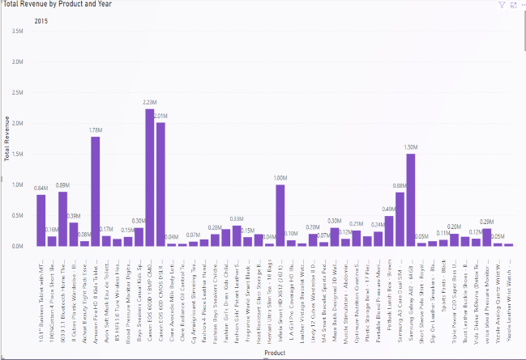 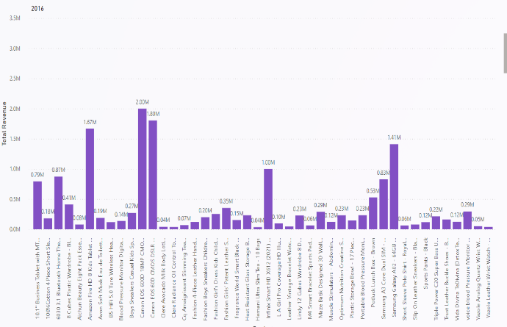

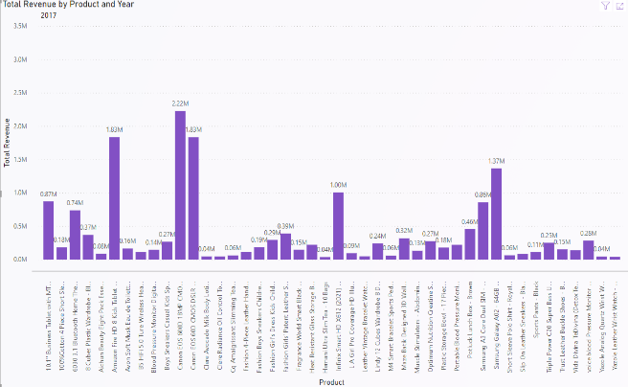 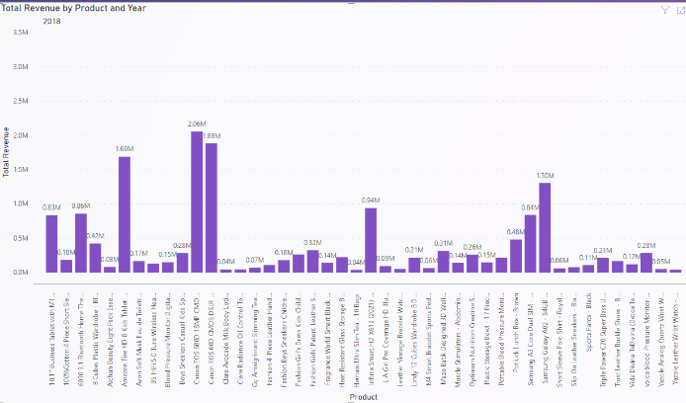

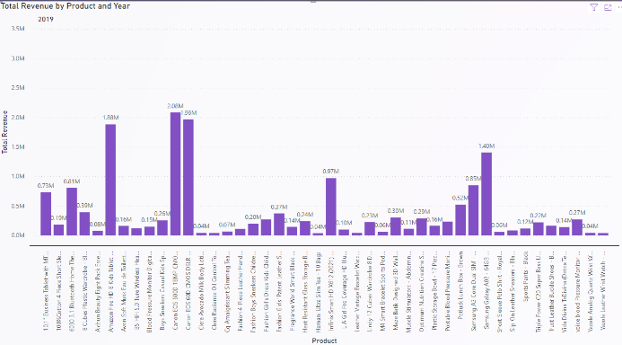 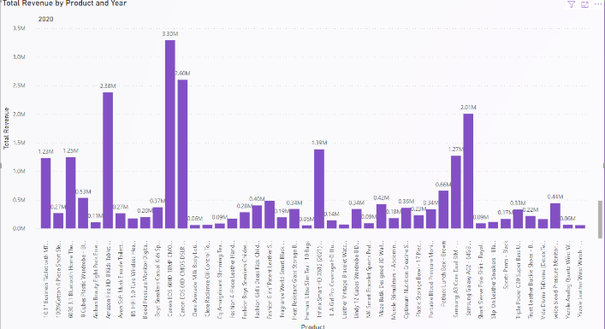

**The revenue breakdown by product category and year is as follows:**

* **Phones and Tablets:**
* **Consistently high revenue, reaching 60M in 2020.**
* **Suggestion: Continue to innovate and offer new features to maintain growth.**
* **Electronics:**
* **Stable revenue around 14M-15M annually.**
* **Suggestion: Introduce new products or offer discounts to boost sales.**
* **Fashion:**
* **Peaked at 21M in 2017, but now consistently around 13M-14M.**
* **Suggestion: Analyse trends, introduce popular styles, and improve marketing strategies.**
* **Health and Beauty, and Home and Office:**
* **Both stable around 13M-19M.**
* **Suggestion: Enhance online visibility, offer bundled deals, or loyalty programs.**

**In summary, focus on innovation, market analysis, and strategic marketing to increase sales of low-performing items.**

[**For increasing the sales of low-selling items, consider these strategies**](https://emailanalytics.com/ways-to-increase-sales/)**:**

* **Bundle Products: Combine low-selling items with popular ones to increase their appeal.**
* **Offer Discounts: Limited-time offers can attract more customers.**
* **Improve Product Visibility: Feature low-selling items prominently in marketing materials.**
* **Gather Customer Feedback: Understand why these items are not selling well and address the issues.**
* **Marketing Campaigns: Create targeted campaigns to highlight the benefits of these products.**
* **Sales Training: Educate your sales team on how to sell these items effectively.**

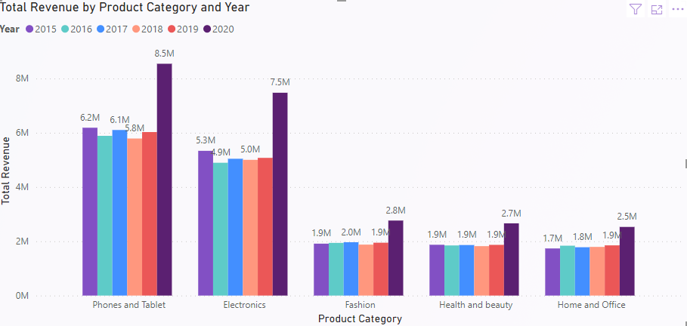

1. How many products were returned? Use a DAX function to get this metric. Examine the possible reasons for returns and consider how this metric could indicate improvements in product descriptions or quality control.

Ans: **In order to perform this task, We will use below DAX function:**

**Measure: Total Number of Return Product = COUNTROWS(FILTER(Orders,Orders[Status] = “Returned”))**

* **Visualization: We can use Card to visualize the count of returned products and there are 31K products have been returned**
* **Analysis: To understand the reasons for product returns, we recommend using a “Table” visual. In this table, we can list the returned products alongside their associated reasons. Based on the screenshot provided, it appears that 6065 products were returned due to “Quality and defective item” issues.**
* **Areas of Improvement:**
* **Product Descriptions:**
* **Regularly review and update product descriptions to ensure accuracy and clarity. Clear descriptions can help manage customer expectations and reduce the likelihood of returns.**
* **Quality Control Measures:**
* **Implement stricter quality control processes during production. This will help minimize the number of defective products reaching customers.**
* **Training for Customer Service Representatives:**
* **Provide additional training to customer service representatives. Equipping them with the necessary skills will enable them to handle return requests more efficiently and effectively.**
* **Customer Feedback:**
* **Gather feedback from customers about their return experiences. Use this valuable information to improve overall product quality and enhance customer satisfaction.**
* **Transport Mode Selection:**
* **Opt for accurate transport modes when delivering products. Choosing the right mode can reduce the chances of product defects during transit.**

**These steps should contribute to better product quality, customer satisfaction, and a reduction in returns.**

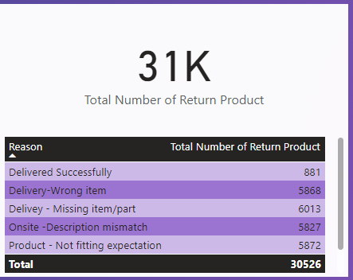

.

1. Whenever a customer goes to Amazon, they’ll filter the most rated products to buy the better category. Can you verify this using any visualization or table that the ratings of products impact their sales value?

Ans: **When customers visit Amazon, they often filter products based on ratings to make informed purchasing decisions. To verify whether ratings significantly impact sales value, we can follow these steps:**

* **Visualization:**
* **Created a Bar Chart with the following axes:**
* **X-axis: Product**
* **Y-axis: Total sales (sum of sales)**
* **Legends: Ratings**
* **The screenshot below illustrates this visual representation.**
* **Analysis:**
* **Examine the Bar Chart:**
* **Highest selling products tend to have ratings between 2 and 3.**
* **Average selling products typically have ratings between 4 and 5.**
* **However, this alone does not conclusively prove the impact of ratings on sales.**
* **Consider other factors:**
* **Product quality: High ratings may correlate with better quality, leading to increased sales.**
* **Marketing efforts: Effective marketing can boost sales regardless of ratings.**
* **Customer reviews: Positive reviews can influence potential buyers.**
* **To validate the impact of ratings, perform statistical tests or regression analysis.**
* **Conclusion:**
* **While ratings provide valuable information, they are not the sole driver of sales.**
* **A holistic approach, considering various factors, is essential for a comprehensive understanding.**

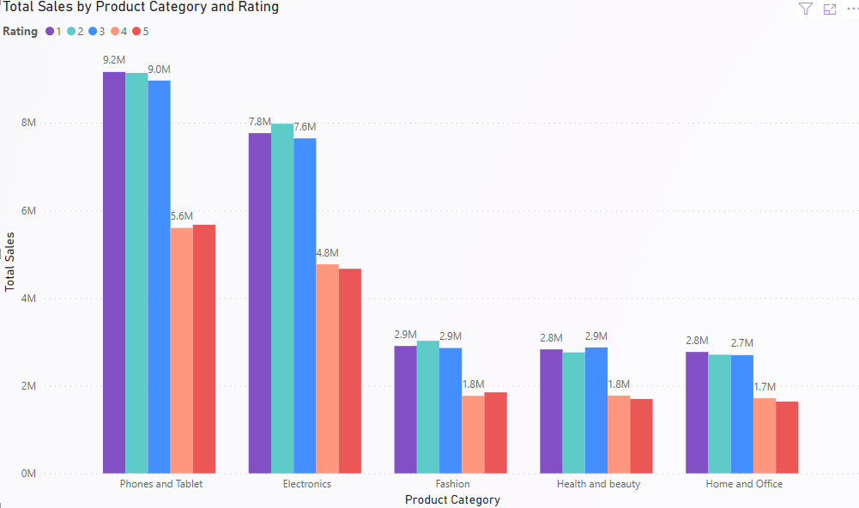

1. Investigate how revenue distribution varies across different locations. Explore which geographical areas contribute most to sales and consider the strategic implications for regional marketing and distribution efforts. How might location-based trends inform the company's market segmentation and resource allocation approach?

Ans: **To investigate revenue distribution across different locations and understand which geographical areas contribute most to sales, follow these steps:**

* **Visualization:**
* **Utilized a Map chart to display revenue distribution across various locations.**
* **Placed Location on the map and represent total revenue using bubble size.**
* **The screenshot below illustrates this visual representation.**
* **Analysis:**
* **Examine the map chart:**
* **Identify regions with the highest revenue (e.g., “Greater Accra” in this case).**
* **Consider other locations that contribute significantly.**
* **Strategic Implications:**
* **Market Segmentation: Use location-based trends to segment your market effectively.**
* **Target high-revenue areas with tailored marketing campaigns.**
* **Understand local preferences and adapt product offerings.**
* **Resource Allocation:**
* **Allocate resources (sales teams, inventory, marketing budget) based on revenue-generating regions.**
* **Prioritize expansion efforts in promising locations.**
* **Optimize supply chain and distribution networks for efficient delivery.**
* **Competitive Advantage:**
* **Leverage insights to outperform competitors in specific regions.**
* **Identify untapped markets for potential growth.**
* **Risk Mitigation:**
* **Diversify across locations to reduce dependency on any single market.**
* **Monitor revenue fluctuations and respond proactively.**
* **Conclusion:**
* **Location-based trends inform critical decisions, impacting market segmentation, resource allocation, and overall business strategy.**



1. Determine which month could benefit from enhanced promotional offers to boost sales. Can you suggest some targeted marketing strategies here?

Ans: **To determine which month could benefit from enhanced promotional offers and boost sales, follow these steps:**

* **Visualization:**
* **Used a line chart to analyse sales trends over time.**
* **Placed Months on the x-axis and the sum of sale price on the y-axis.**
* **The screenshot below illustrates this visual representation.**
* **Analysis:**
* **Examine the line chart:**
* **Identify months with declining sales (e.g., June and September).**
* **These months may be suitable for targeted promotions.**
* **Targeted Marketing Strategies:**
* **Seasonal Promotions:**
* **Offer season-specific discounts or bundles to encourage higher spending during these months.**
* **Leverage holidays, events, or local festivities.**
* **Flash Sales:**
* **Create a sense of urgency by organizing limited-time flash sales.**
* **Highlight exclusive deals available only during specific periods.**
* **Social Media Engagement:**
* **Increase social media presence:**
* **Run interactive content (polls, quizzes, etc.) related to seasonal themes.**
* **Host contests or giveaways to engage customers.**
* **Leverage user-generated content (UGC) to create buzz.**
* **Email Campaigns:**
* **Send targeted emails to existing customers:**
* **Announce special promotions.**
* **Remind them of upcoming flash sales.**
* **Personalize offers based on their preferences.**
* **Localized Advertising:**
* **Tailor advertising efforts to specific regions:**
* **Use local events or cultural references.**
* **Collaborate with local influencers.**
* **Cross-Sell and Upsell:**
* **Suggest related products during checkout.**
* **Bundle complementary items to increase the average transaction value.**
* **Resource Allocation Approach:**
* **Allocate marketing budgets, staffing, and inventory based on the targeted strategies.**
* **Prioritize efforts during the identified months.**
* **Monitor results and adjust as needed.**
* **Conclusion:**
* **By strategically enhancing promotions during specific months, you can optimize sales and improve overall business performance.**

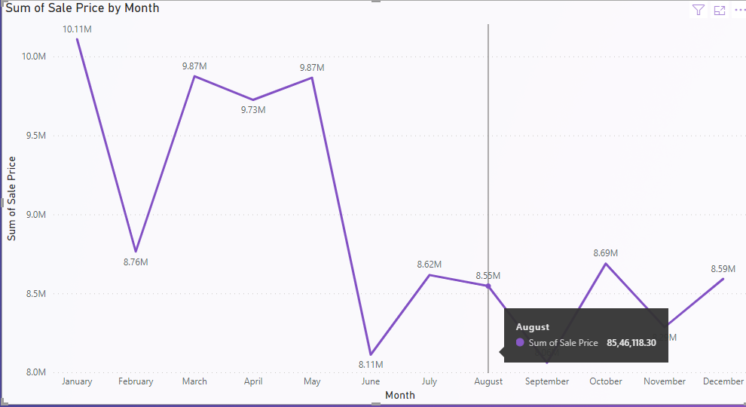

1. Identify which products may require increased marketing efforts. Which items have high prices yet underperform in sales?

Ans:

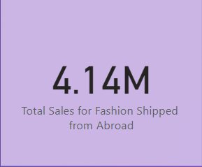

1. Assess which products should have discounts. How can targeted incentives drive sales and customer loyalty for specific products?

Ans: **- Identifying Products for Discounts and Using Targeted Incentives**

**As observed in Question 6, the Canon EOS 60D CMOS DSLR Camera stands out as a highly priced product with the lowest sales among all the items. To address this, we can strategically offer discounts on high-priced products with low sales. Targeted incentives play a crucial role in driving sales and fostering customer loyalty for specific products. Here’s how you can effectively utilize them:**

* **Identify Your Target Audience:**
* **Understand your customer base by segmenting them based on demographics, purchase history, preferences, and behaviour.**
* **Tailor incentives to specific customer groups who are most likely to be interested in the product.**
* **Personalized Offers:**
* **Create customized incentives that resonate with each customer segment.**
* **Examples include exclusive discounts, rewards points, freebies, or special promotions specifically targeted at certain products.**
* **Personalization enhances the relevance of the incentive and makes customers feel valued.**
* **Promote Scarcity and Urgency:**
* **Use targeted incentives to create a sense of scarcity and urgency around the product.**
* **Limited-time offers, flash sales, or exclusive access to new products can motivate customers to make a purchase quickly before missing out on the deal.**
* **Implement Loyalty Programs:**
* **Set up loyalty programs that offer rewards or incentives for repeat purchases of specific products.**
* **Encourage customer loyalty by providing additional benefits for consistently choosing your brand.**
* **Leverage Referral Programs:**
* **Encourage customers to refer their friends and family to purchase the targeted product.**
* **Offer incentives such as discounts, credits, or freebies for both the referrer and the new customer.**

1. Come up with a loyalty program to benefit the company’s customers. From the available lot of customers come up with strategies to bucket them and provide benefits under different loyalty programs.

Ans: **A well-designed customer loyalty program can significantly impact customer retention, drive repeat business, and enhance brand loyalty. In this proposal, we’ll outline strategies for creating a successful loyalty program and customizing it to benefit different customer segments.**

* **Understand Your Customer Base**
* **Start by analysing existing customer data to identify key segments. Consider factors such as demographics, behaviour, and preferences. Segmentation allows you to tailor incentives effectively.**
* **Segmentation Strategies**
* **Tiered Programs:**
* **Create different loyalty tiers (e.g., Gold, Silver, Bronze) based on customer value.**
* **Each tier offers escalating benefits (e.g., higher discounts, exclusive access).**
* **Behaviour-Based Segmentation:**
* **Reward specific behaviours (e.g., frequent purchases, referrals, social media engagement).**
* **Demographic Segmentation:**
* **Customize benefits for different age groups, professions, or interests.**
* **Program Elements**
* **Points System:**
* **Assign points for every purchase.**
* **Accumulated points can be redeemed for discounts, free products, or exclusive experiences.**
* **Discounts and Offers:**
* **Regularly provide discounts, early access to sales, or exclusive promotions.**
* **Personalized Rewards:**
* **Tailor rewards based on individual preferences (e.g., favourite products, special occasions).**
* **VIP Treatment:**
* **Offer priority customer service, personalized assistance, and exclusive events.**
* **Referral Bonuses:**
* **Encourage customers to refer friends by offering rewards for successful referrals.**
* **Communication Channels**
* **Use email, SMS, and push notifications to keep customers informed about program updates, rewards, and special events.**
* **Leverage social media to engage with program members and share success stories.**
* **Feedback and Adaptation**
* **Collect feedback from program participants regularly.**
* **Monitor program performance metrics (e.g., retention rates, repeat purchases, customer lifetime value).**
* **Adapt the program based on insights and customer preferences.**
* **Examples of Benefits**
* **Bronze Tier (Entry Level):**
* **Points for every purchase.**
* **Birthday discounts.**
* **Silver Tier (Intermediate):**
* **Higher point accumulation rate.**
* **Exclusive early access to sales.**
* **Gold Tier (Top Level):**
* **Personal shopper assistance.**
* **Invitations to VIP events.**
* **Surprise gifts.**
* **Launch and Promote**
* **Announce the loyalty program through various channels (website, social media, in-store).**
* **Encourage sign-ups with an initial bonus (e.g., welcome points).**

1. Using the DAX functions Calculate and a row iteration DAX function calculate the total sales for the Product Category “Fashion” and delivery type “Shipped from Abroad”. What are the other types of DAX functions you have used in the project?

Ans: **- In order to calculate the total sales for the Product Category “Fashion” and delivery type “Shipped from Abroad” we have to use following DAX Measure**

**Measure: Total sales for fashion = CALCULATE(SUMX(Orders, Orders[Sale Price]), Orders[Product Category] = “Fashion”, Orders[Delivery Type] = “Shipped from Abroad”)**

**Visualization: You can represent this data using a card visualization.**

**Analysis: The total sales for fashion items shipped from abroad amount to 4.14 million.**



1. Wait Times Correlated with Demographics and Care: Explore how average wait times vary across different product categories to optimize scheduling and staffing.

Ans: **- The visualization to shows positive correlations using a scatter plot.**

* **Visualization:**
* **Utilize a scatter plot to analyze average wait times over time.**
* **Place months or years (according to need) from the Order Date on the x-axis.**
* **Represent the average wait time on the y-axis.**
* **Group the data by product category.**
* **Color code the data points to indicate positive correlations.**
* **Analysis:**
* **Examine the scatter plot:**
* **Identify trends in average wait times for each product category.**
* **Look for clusters of data points indicating positive correlations between wait times and specific months or years.**
* **Optimization Strategies:**
* **Staffing Adjustments:**
* **Allocate more staff during peak wait times.**
* **Ensure adequate coverage for high-demand periods.**
* **Scheduling Optimization:**
* **Schedule breaks and shifts strategically to manage wait times.**
* **Consider staggered shifts to handle fluctuations.**
* **Product Category Insights:**
* **Identify which product categories contribute most to wait times.**
* **Prioritize resources accordingly.**
* **Customer Communication:**
* **Set realistic expectations for wait times.**
* **Provide estimated wait times during interactions.**
* **Process Improvements:**
* **Streamline processes to reduce wait times.**
* **Optimize call routing and handling procedures.**
* **Resource Allocation Approach:**
* **Allocate staffing resources based on the insights from the analysis.**
* **Adjust schedules and staffing levels as needed.**
* **Conclusion:**

**By understanding positive correlations between wait time variations across product categories, you can enhance customer experience and operational efficiency.**

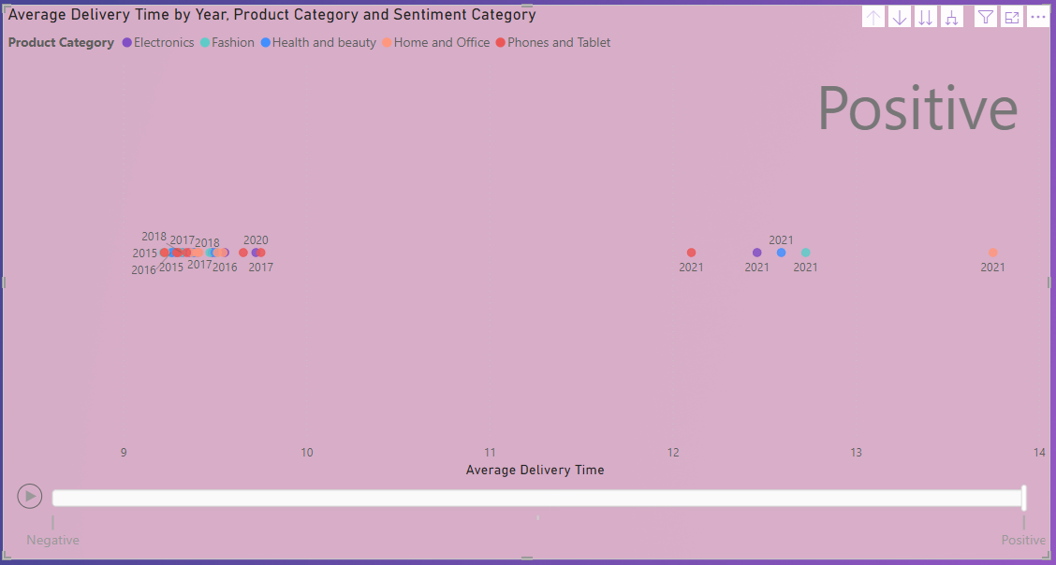

1. Explore if there is any relationship between the Delivery type and waiting time between ordering and receiving an item.

Ans: **This analysis explores the relationship between delivery type and the waiting time between ordering and receiving an item. By understanding this relationship, we can optimize scheduling and staffing for better customer experience.**

* **Visualization**

**We have used a bar chart to compare average waiting times based on different delivery types:**

* **Shipped from Abroad: The average waiting time is approximately 15.0 days.**
* **Standard Delivery: The average waiting time is approximately 10.0 days.**
* **Express: The average waiting time is approximately 3.5 days.**
* **Analysis**
* **Comparison:**
* **The “Express” delivery type has the shortest average waiting time, making it ideal for customers who need quick delivery.**
* **“Standard Delivery” falls in the middle, providing a balance between speed and cost.**
* **“Shipped from Abroad” has the longest waiting time, likely due to international shipping.**
* **Resource Allocation:**
* **Allocate resources based on delivery type trends.**
* **Staff adequately during peak delivery times for each type.**
* **Customer Expectations:**
* **Set realistic delivery expectations based on the chosen delivery type.**
* **Communicate estimated wait times to customers during the ordering process.**
* **Conclusion**
* **Understanding delivery time variations helps enhance customer satisfaction and operational efficiency. Choose the right delivery type based on customer needs and business priorities.**

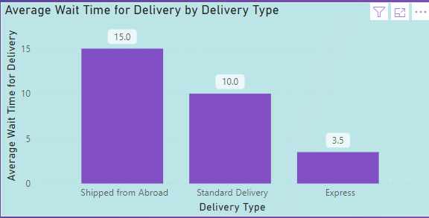

1. Is there any relationship between shipping charges and product type?

Ans: There is no direct relationship between shipping charges and product type. But the **Yes, there is a relationship between shipping charges and delivery type. We can visualize this relationship using a line chart:**

* **Visualization:**
* **Created a line chart.**
* **Placed delivery type on the x-axis.**
* **Represent shipping Fee on the y-axis.**
* **Analysis:**
* **Observe the chart:**
* **“Shipped from Abroad” has the highest shipping charges.**
* **“Standard Delivery” has the lowest shipping charges.**
* **Use this insight to optimize logistics and cost management.**

**Understanding this relationship helps improve decision-making related to shipping and delivery.**

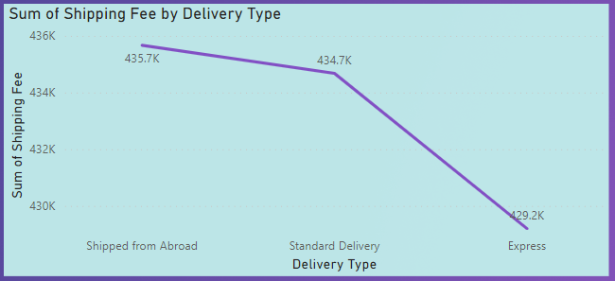

1. Come up with strategies to decrease the low rating orders after analyzing different factors like waiting time, shipping type, unit price, etc.

Ans: **- here are some strategies to decrease low-rating orders based on the analysis of various factors such as waiting time, shipping type, and unit price:**

* **Analyse the Factors:**
* **Waiting Time:**
* **Investigate delays in order processing and delivery.**
* **Identify bottlenecks and streamline the fulfilment process.**
* **Set realistic delivery expectations for customers.**
* **Shipping Type:**
* **Evaluate the impact of different shipping methods (e.g., standard, express, same-day).**
* **Optimize logistics based on customer preferences and cost-effectiveness.**
* **Unit Price:**
* **Assess the relationship between product pricing and customer satisfaction.**
* **Consider pricing adjustments if high-priced items receive low ratings.**
* **Strategies to Decrease Low-Rating Orders:**
* **Quality Control:**
* **Implement rigorous quality checks before shipping.**
* **Ensure accurate product descriptions and images.**
* **Customer Communication:**
* **Provide real-time order updates.**
* **Address customer inquiries promptly.**
* **Feedback Loop:**
* **Encourage customers to leave reviews.**
* **Use feedback to improve processes.**
* **Staff Training:**
* **Train staff on order accuracy and customer service.**
* **Empower them to handle customer concerns effectively.**
* **Returns Management:**
* **Simplify return processes.**
* **Analyse return reasons to identify patterns.**
* **Supply Chain Optimization:**
* **Maintain optimal inventory levels.**
* **Optimize supplier relationships.**
* **Data-Driven Decisions:**
* **Continuously monitor metrics (e.g., Order Defect Rate, customer feedback).**
* **Use insights to refine strategies.**
* **Resource Allocation Approach:**
* **Allocate resources (staff, technology, inventory) based on the identified strategies.**
* **Prioritize areas with the highest impact on customer satisfaction.**

1. Using the time intelligence DAX function, create a table to compare each month’s sales with the previous year’s same month’s total sales. So there will be four columns in the output year, month, total sales, previous_years_sales.

Ans: **DAX for Previous Year Sales:**

**The DAX given is:**

**Previous Year Sales = CALCULATE([Total Revenue], SAMEPERIODLASTYEAR(Orders[Order Date]), ALLEXCEPT(Orders, Orders[Order Date]))**

**This DAX calculates the total revenue for the same period last year, considering the context of the Orders table and the Order Date column. It uses the SAMEPERIODLASTYEAR function to get the sales from the previous year.**

**The ALLEXCEPT function ensures that only the Order Date context is preserved while removing other filters.**

* **Visualization:**
* **The answer suggests visualizing this data using a table. Unfortunately, there is no screenshot provided, so we cannot directly assess the visualization.**
* **However, creating a table with columns for year, month, total sales, and previous year’s sales would indeed be an appropriate way to present this information.**
* **Analysis:**
* **The analysis states that the revenue of the company is increasing every year. However, without the actual data or visualization, we cannot verify this claim.**
* **To validate this statement, we would need to compare the total sales for each month across different years.**

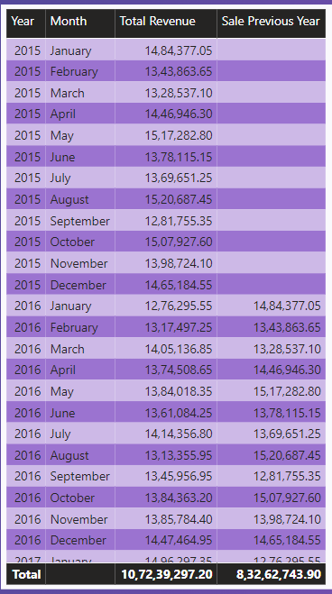

1. What do you understand by PowerBI gateway? What are its use cases?

**Answer - Power BI Gateway: A crucial component within the Power BI ecosystem, the Power BI Gateway facilitates secure data flow between on-premises data sources and the cloud-based Power BI Service. Its primary purpose is to keep your Power BI reports and dashboards up-to-date by connecting to data sources that aren’t directly accessible from the cloud.**

**Here are the two types of Power BI Gateway:**

* **Standard Mode: Typically used at the enterprise level, the standard mode serves multiple users and provides access control per data source.**
* **Personal Mode: Designed for individual use, the personal mode runs as a single user with personalized credentials.**

**Now, let’s explore the key use cases for Power BI Gateway:**

* **Data Refresh: Ensures that reports and dashboards in Power BI stay current by fetching the latest data from internal databases, files, or other on-premises sources.**
* **Data Security and Compliance: Organizations can maintain data control by using the gateway to keep sensitive information within their network perimeter. This addresses security and compliance requirements, especially for data that cannot be stored or processed in the cloud due to regulations or organizational policies.**
* **Live Connection: Power BI Gateway enables real-time connections to on-premises data sources. Users can create reports and dashboards in Power BI Service that directly link to on-premises data without storing it in the cloud.**
* **Diverse Data Source Support: Power BI Gateway accommodates various data sources, including SQL Server, SharePoint, Oracle, SAP HANA, Teradata, and more.**

1. How would you approach this problem, if the objective and subjective questions weren't given?

**Answer - Approaching the Amazon Sales Problem: A Systematic Approach**

* **Initial Data Exploration:**
* **Begin by exploring the dataset to understand its structure, including available tables, columns, and relationships.**
* **Identify key variables such as product information, customer details, and order dates.**
* **Define Objectives:**
* **Clarify the goals and objectives of the analysis.**
* **Understand business needs, identify key performance indicators (KPIs), and determine areas of focus (e.g., sales performance, customer behaviour, or product trends).**
* **Data Cleaning and Preparation:**
* **Clean the data to address inconsistencies, missing values, and data format issues.**
* **Tasks include:**
* **Removing duplicate records.**
* **Standardizing data formats.**
* **Handling null values appropriately.**
* **Ensuring data integrity and consistency.**
* **Statistical Analysis and Modelling:**
* **Perform statistical analysis and modelling to uncover relationships, patterns, or correlations in the data.**
* **Visualization and Reporting:**
* **Create visualizations using charts, graphs, and dashboards to communicate insights effectively.**
* **By following these steps, you can systematically approach the Amazon sales problem and derive meaningful insights.**